Practical - 7
Practical Title: PHP Form Processing with Server-Side Validation and CSV/JSON File Storage

Problem Definition: Process submitted registration/contact form data using PHP. Validate and sanitize inputs on the server side and store records in CSV or JSON file format. Display success/error messages.

Theory

Is the form submitted using POST?
Answer: Yes, the form data is submitted using the POST method. PHP receives the submitted values through $_POST, which allows the data to be processed on the server without putting the form values in the URL.

Are inputs validated and sanitized server side?
Answer: Yes, the submitted data is validated and sanitized in PHP before storing it. Required fields are checked, and values such as email, mobile number, and password are checked for the correct format. Unwanted spaces or unsafe input can also be removed or handled properly.

3. Is file writing handled safely?
Answer: Yes, the validated data is stored in a CSV or JSON file using PHP file-handling functions. The file is opened or updated carefully so that existing records are not accidentally lost. Data is converted into the correct format before writing.

4. Are success and error responses displayed clearly?
Answer: Yes, after processing the form, PHP displays a success message when the data is stored correctly. If validation fails or there is a problem while saving the data, an appropriate error message is displayed so the user knows what needs to be corrected.

Implementation/ Output/Result
- Created an HTML registration form to collect user details.
- Used the POST method to submit the form data securely to the PHP processor.
- Used PHP's $_POST to receive the submitted form values.
- Added server-side validation to check required fields and validate inputs such as email, mobile number, and password.
- Used PHP file-handling functions to store the records safely in the data file.
- Displayed a success message when the record was stored successfully.
- Displayed appropriate error messages when validation or file processing failed.
- Tested the form with both valid and invalid inputs to verify the complete process.

Evidence of Work (Screenshots)
Figure 1.1 Meesage Display
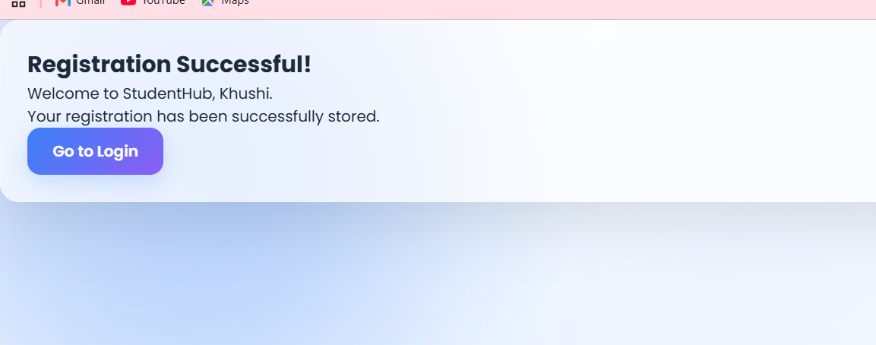
Description: Successful message is displayed when registration is successful.
Figure 1.2 Failed login display page
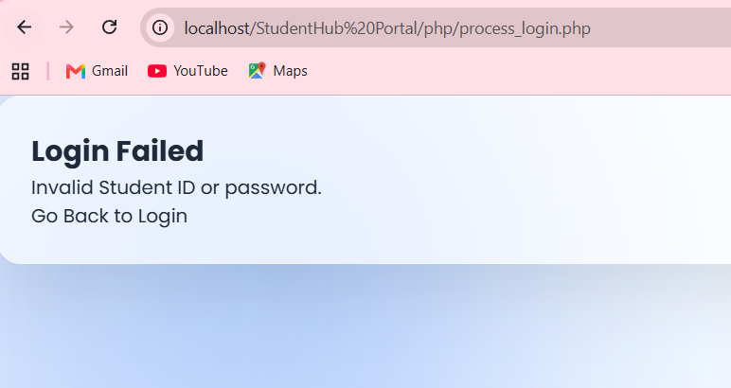
Description: Displaying message when login fails
Figure 1.3 Error message
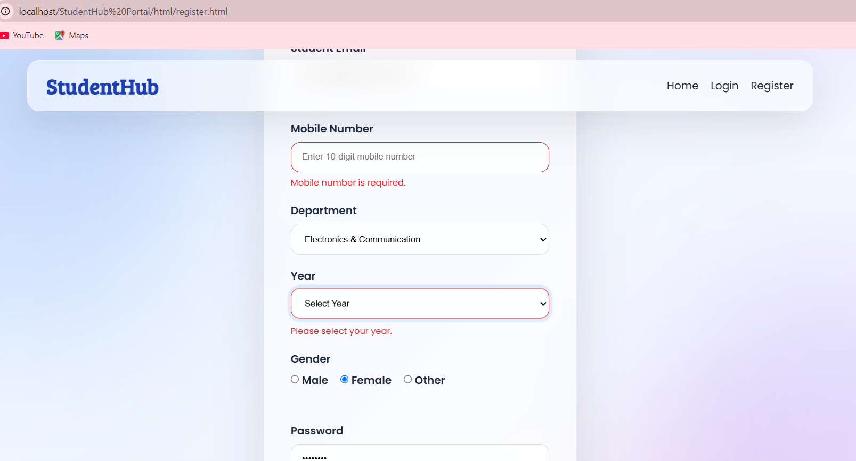
Description: Message is displayed when fields are empty or incorrect.
Figure 1.1 JSON file
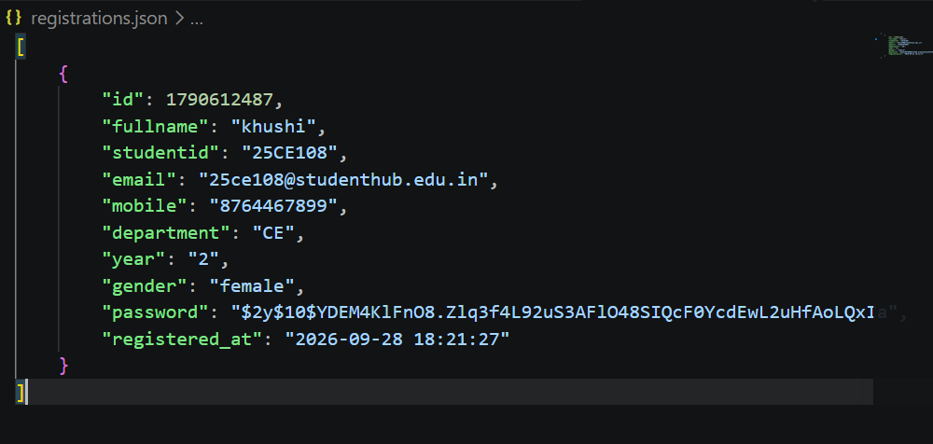
Description: JSON file that stores data from registration form

GitHub Repository Link:
https://github.com/heerce27/StudentHub-Portal.git

Challenges Faced:

Handling incorrect or empty inputs without causing errors was a challenge.

Making sure that old records were not overwritten while adding new records required careful file handling.

Learning Outcomes:

Learned how to process HTML forms using PHP and the POST method.

Understood the importance of server-side validation and input sanitization.

Learned how to receive and process form data using $_POST.

Learned how to store form records in JSON files using PHP.

Faculty Remarks:

